CASE STUDY
Enterprise Strategy Agent (ESA)
Multi-Agent Enterprise Intelligence System

EXECUTIVE SUMMARY
Problem → Fragmented enterprise data and slow, manual decision workflows.
Solution → Multi-agent AI system integrating search, analytics, benchmarking, and strategy generation.
Outcome → 85% faster insight generation and 66% reduction in decision cycle time.

1. Problem Statement

Industry / Customer Context
- Large enterprise organizations
- Multi-department operations (Finance, Strategy, Product, Operations)
- Global data footprint
- High dependency on dashboards, documents, and external research

Organizations operated across:
- Structured data (CSV, Excel, databases)
- Unstructured data (PDFs, presentations, policies)
- External intelligence platforms
- Multiple analytics and reporting tools

Core Problem Identified
Enterprise decision-making was fragmented and slow.

What was broken:
- Data retrieval required manual search across systems
- Analytics required separate BI tools
- External benchmarking required independent research workflows
- Strategy synthesis was manual and slide-driven
- No unified intelligence layer connecting all workflows

Teams relied on 4–7 tools per strategic decision cycle.

Supporting Data Points (Baseline)
Metric | Before ESA
Average insight turnaround time | 5–10 business days
Strategy deck preparation time | 2–3 days
Cross-tool switching per workflow | 4–7 platforms
Data processing time (1M rows) | 20–30 seconds
Search relevance (semantic accuracy) | Baseline keyword-driven
Decision cycle duration | ~3 weeks

Why It Mattered
Strategic Risk Areas:
- Slower executive decision cycles
- Delayed market response
- Redundant analyst workload
- Increased operational overhead
- Limited real-time visibility for leadership

Without improvement, enterprises risk:
- Reduced competitive agility
- Missed market opportunities
- Inefficient capital allocation
- Overdependence on manual consulting workflows

2. Impact of the Problem
(Functional, Emotional & Organizational Pain)

Operational Pain
- Analysts manually aggregating data from multiple systems
- Repetitive slide creation for strategy reviews
- Disconnected search and analytics workflows
- Delays due to inter-team data dependencies
- Rework caused by inconsistent document versions

Emotional Impact
- Leadership operating in reactive mode
- Lack of confidence in real-time data
- Pressure during quarterly reviews
- Continuous firefighting before board meetings

Social / Organizational Consequences
- Cross-team friction over data ownership
- Inconsistent reporting standards
- Delayed alignment across departments
- Reduced executive trust in data pipelines

Cost of Inaction
If unchanged:
- 2–3 week decision cycles remain standard
- Analyst productivity capped by manual effort
- Increased reliance on external consultants
- Strategy execution lagging behind competitors
- Higher operational cost per strategic initiative

3. Solution Provided
(Pain Relievers & Gain Creators)

Solution Overview
Designed and deployed the Enterprise Strategy Agent (ESA) — a multi-agent AI intelligence platform that integrates enterprise search, analytics, benchmarking, and strategy generation into a single conversational interface.

Key Features Implemented
1. Multi-Agent Orchestration Layer
→ Pain Relieved: Eliminated tool fragmentation
→ Gain Created: Unified intelligence workflow

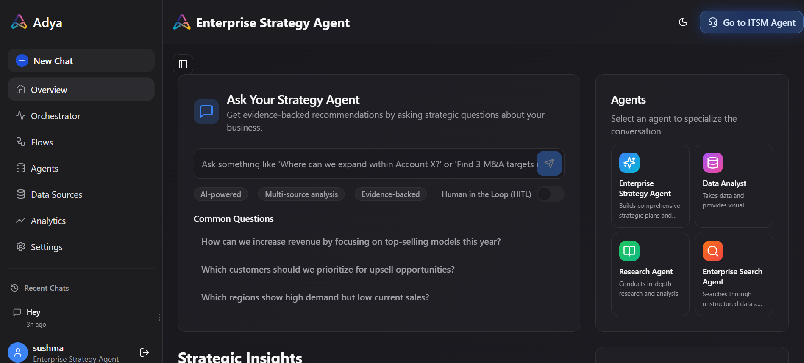

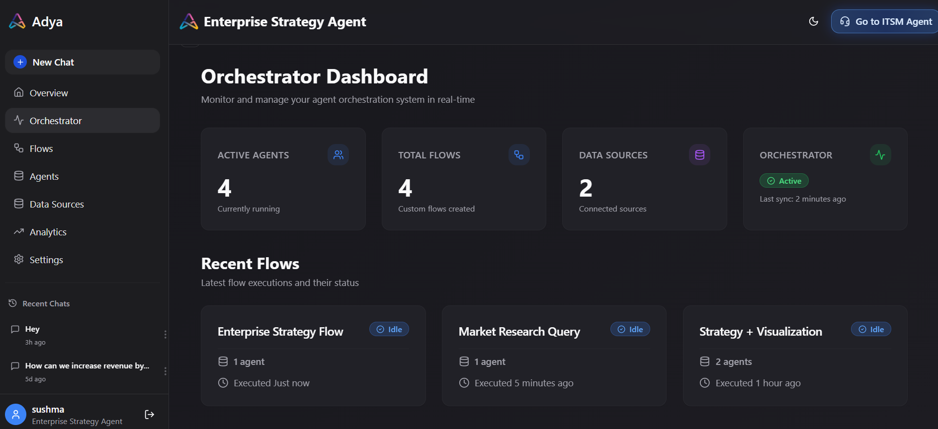

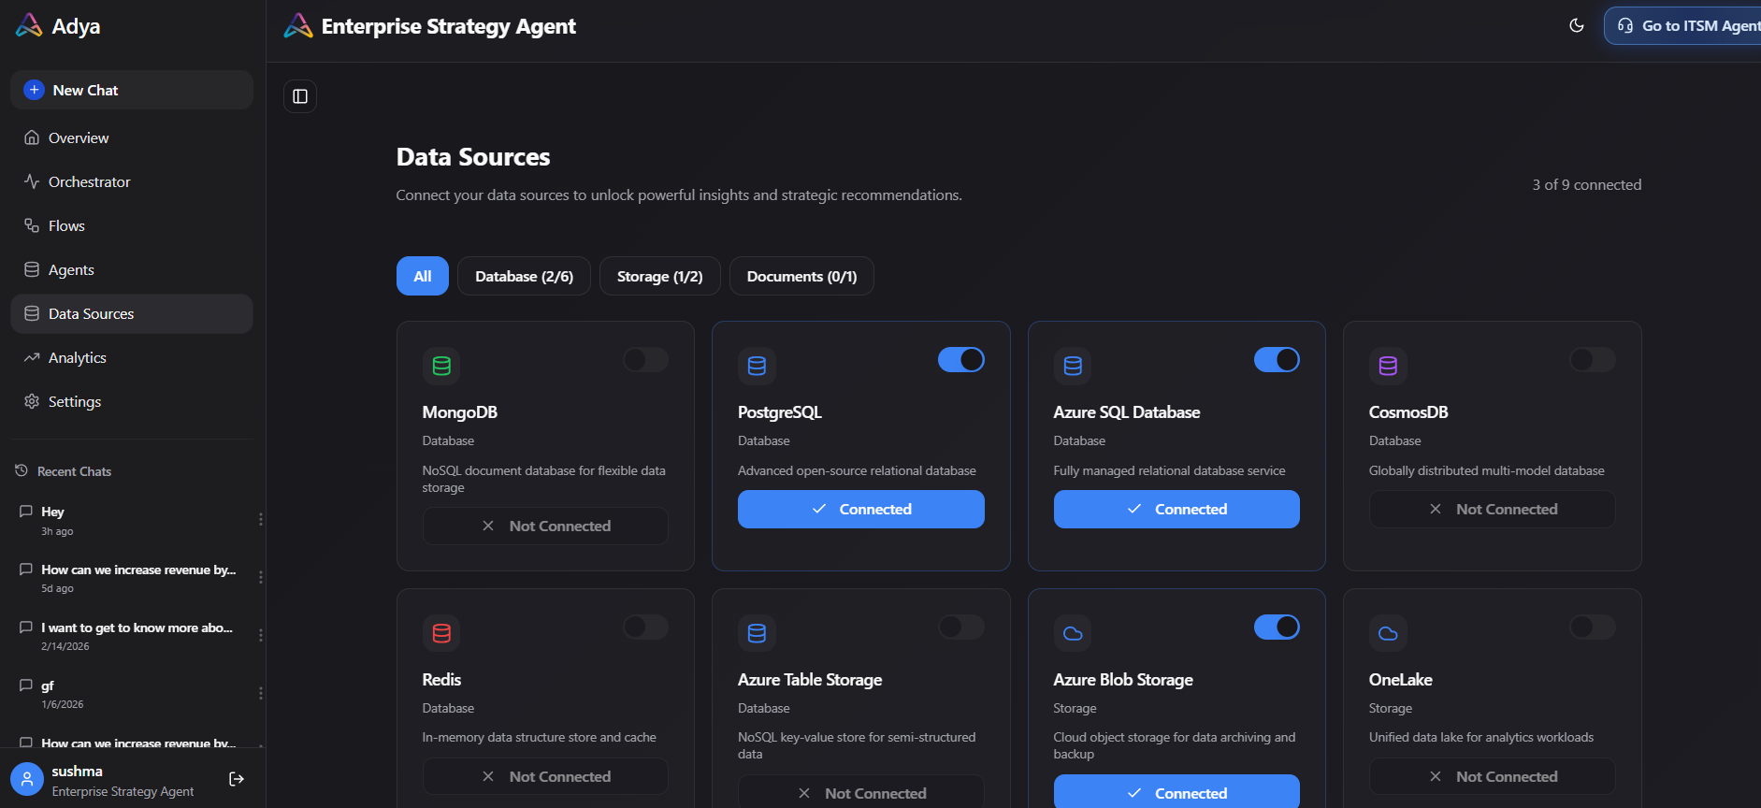

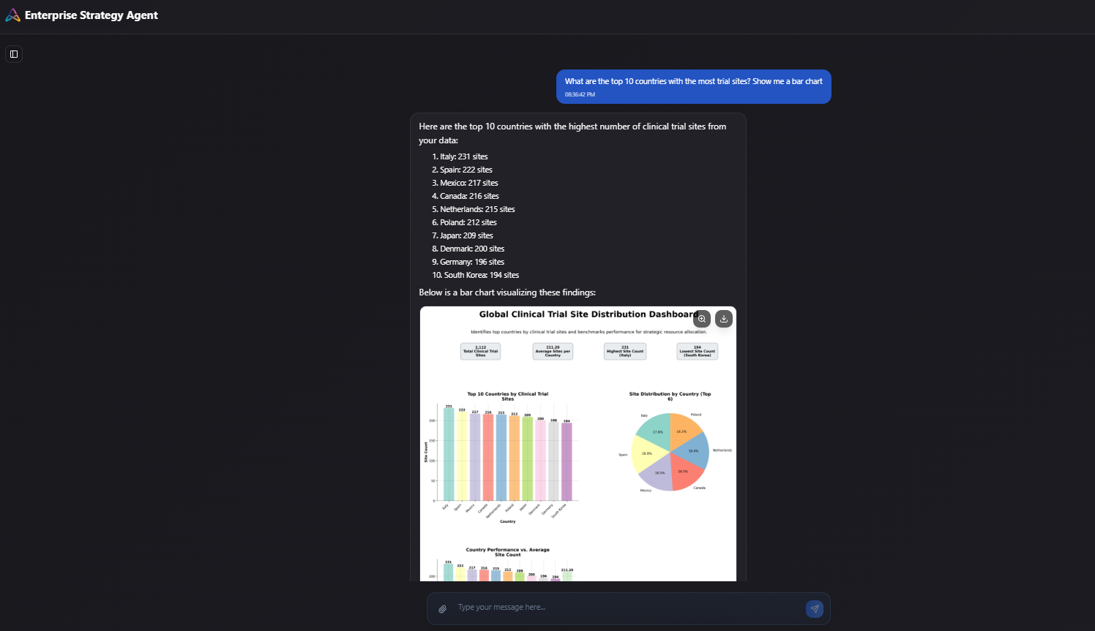

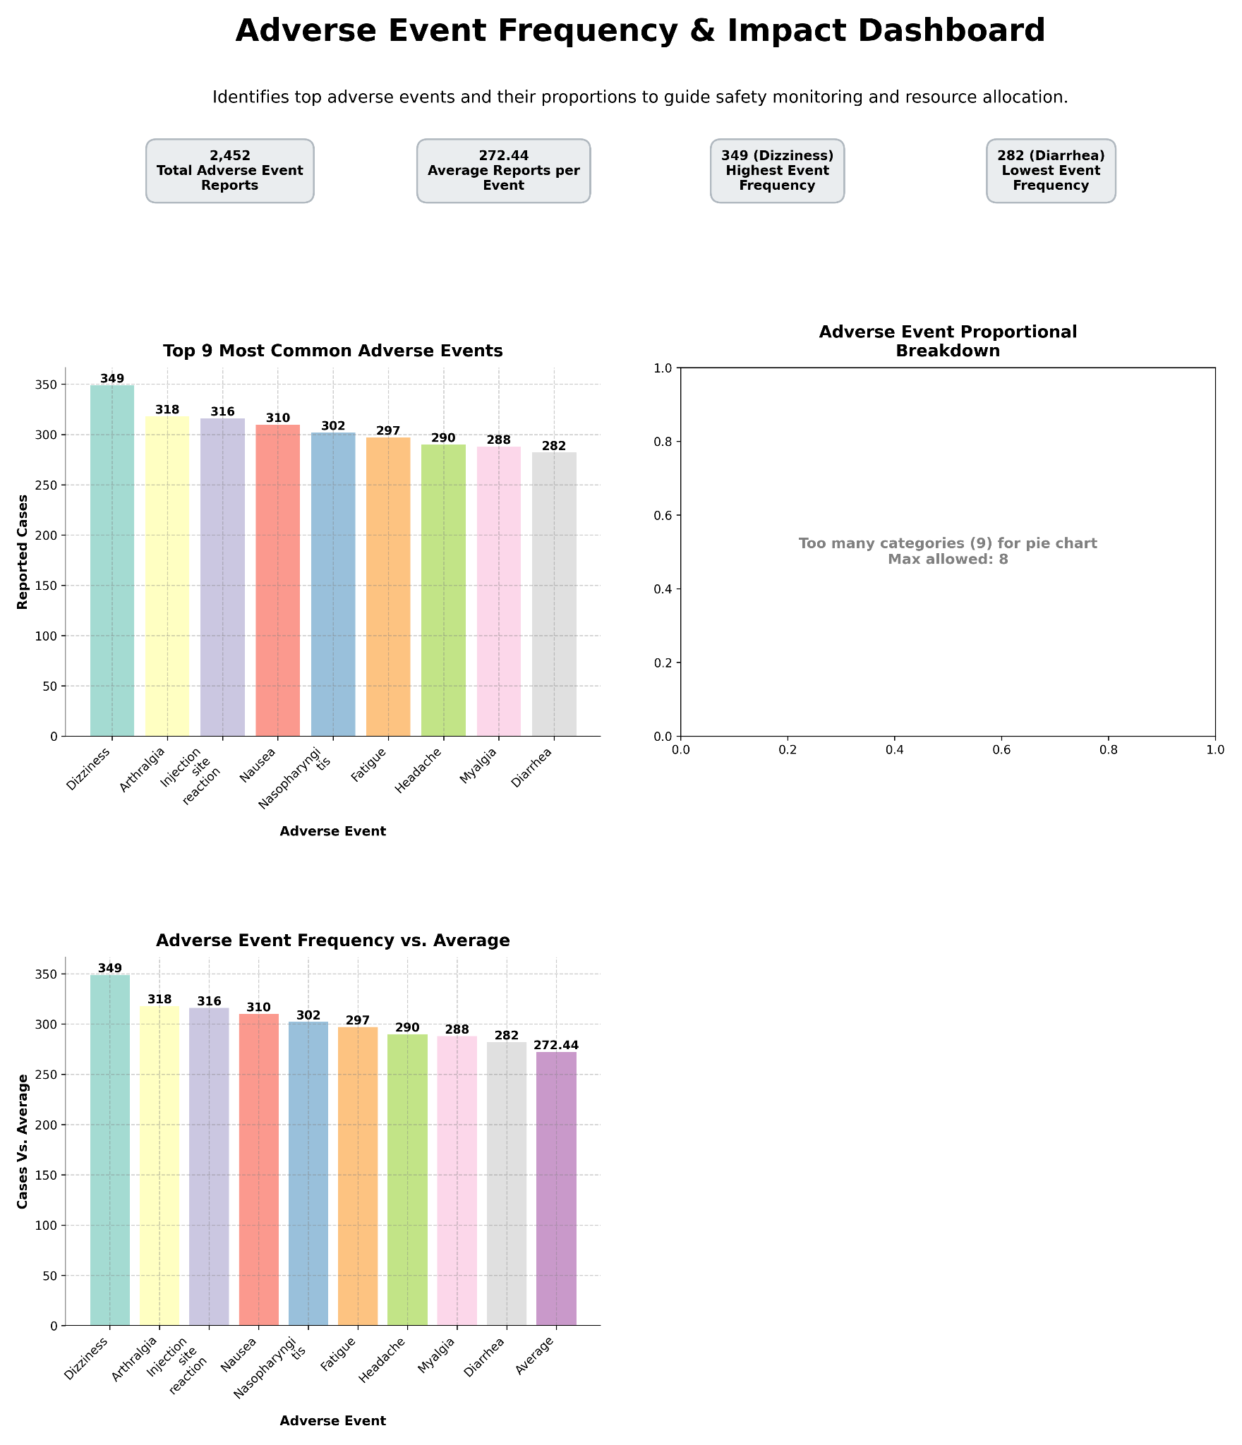
2. Enterprise Search Agent
- Semantic retrieval using embeddings
- Hybrid keyword + vector search
→ Pain Relieved: Manual document hunting
→ Efficiency Impact: Faster knowledge discovery

3. Data Analyst Agent
- Time-series, regression, anomaly detection
- Automated visualization generation
- Parallel data processing
→ Gain Created: Self-service analytics
→ Efficiency Impact: Reduced dependency on BI tools

4. Research Agent
- External benchmarking
- Competitive landscape analysis
- Industry trend extraction
→ Gain Created: Faster evidence-backed decision-making

5. Strategy Agent (Core Layer)
- GTM planning
- Scenario modeling
- Resource allocation optimization
- Roadmap creation
→ Revenue/Operational Impact: Structured, data-backed action plans

Implementation Approach
- Timeline: 12–16 weeks
Phase 1: Core search + analytics foundation
Phase 2: External research integration
Phase 3: Strategy synthesis engine
Integration Complexity:
- API-based integrations with internal systems
- Secure access layer (RBAC, ABAC)
- Scalable containerized architecture

Change Management:
- Executive onboarding sessions
- Analyst workflow redesign
- Cross-functional adoption playbooks

Technical Capabilities & Architecture
- Distributed multi-agent framework
- Intent-driven routing engine
- Containerized services (Kubernetes)
- Horizontal auto-scaling
- Parallel processing engine
- Up to 100M row handling capacity
- TLS 1.3 (in transit)
- AES-256 encryption (at rest)
- Role-based and attribute-based access control
- Immutable audit logs

4. Outcome (Quantified Results)

Measurable Results
KPI | Before | After | Improvement
Insight turnaround time | 5–10 days | <1 hour | ↓ 85%
Strategy deck prep time | 2–3 days | 30 minutes | ↓ 75%
Tool dependency | 4–7 tools | 1 platform | Consolidated
Data processing (1M rows) | 20–30 sec | <10 sec | 2–3× faster
Search relevance | Keyword-based | Semantic + re-ranking | 2.3× improvement
Decision cycle time | 3 weeks | 1 week | ↓ 66%

Strategic Impact
- Accelerated enterprise decision velocity
- Reduced operational overhead
- Improved executive confidence in data
- Increased organizational alignment
- Stronger strategic agility

Human Impact
- Significant reduction in analyst workload
- Lower stress before quarterly reviews
- Improved collaboration across departments
- Real-time leadership visibility
- Higher trust in enterprise data systems

